Beyond the Nation: EU

* The EU is a composite of 28 countries
* The strongest economic zone world wide
* The EU brought peace in world and got in 2012 the *Nobel Peace Prize*

**What brought the EU for the citizens?**

* Travel freedom
* Light bulb prohibition
* Bank control
* Stabilized the Euro
* Abolish roaming

In addition, the EU campaigns for environmental commitment, cultural variety, individual liberty, rights, and care for costs and safety.

**The logo of the EU:**

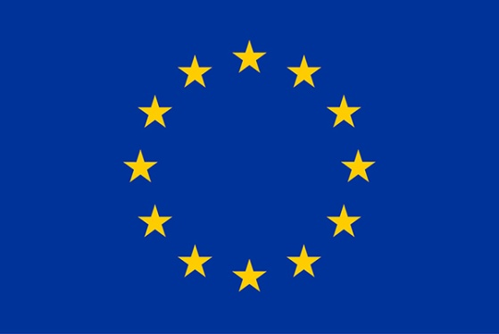

The twelve stars ordered as circle represent Unit, solidarity and harmony between the people of Europe.

**Why is the EU necessary?**

* Guaranteed safety for the countries
* Country wide projects, rights, rules, and decisions